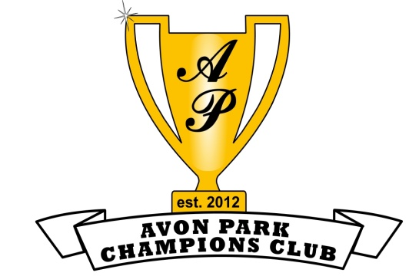

AVON PARK CHAMPIONS CLUB
2020 HALL OF FAME BANQUET

January 7, 2020

Attention Supporters & Local Businesses:

The Avon Park Champions Club is pleased to invite you to attend our 2020 Hall of Fame Banquet. The Hall of Fame was established in 2012 to honor and recognize Avon Park alumni, faculty, administrators, coaches, and local citizens for their outstanding accomplishments and contributions to our schools and community.

The Avon Park Champions Club is planning our Hall of Fame Banquet including an Induction Ceremony. The dinner will be held at Our Lady of Grace Catholic Church’s Grogan Center on March 7, 2020 at 6 pm. The 2020 Hall of Fame Inductees are: C. Elton Crews, Kenny Dixon, Dean Lemler, and David Sizemore.

We are asking you or your business to become a program sponsor. Levels of support are Platinum $500, Gold $250, and Silver $100. All sponsors will have their name in the program and on the banner on display at the banquet. The Platinum level includes two dinner tickets and your company’s name/logo listed at the top of the banner. In order to ensure your company name is listed in the program and on the banner, we must receive payment by February 21st. We have included an order form for your convenience. The menu will include a prime rib dinner with dessert.

Your sponsorship will not only enable us to recognize this year’s recipients but to provide ongoing support for many of our local academic and athletic programs. For the fifth year, the Avon Park Champions Club will again be awarding $1,000.00 scholarships to several deserving Avon Park High School seniors. Lastly, a list summarizing our club’s activities and groups we support is included.

Thank you for your consideration, and we hope to see you on March 7th!

-Avon Park Champions Club Board

Avon Park Champions Club, Inc.
118 S. Lake Ave.
Avon Park, FL 33825
www.apchampionsclub.com

Please fill out this form and email, mail or drop off to:

Avon Park Champions Club, Inc.
118 S. Lake Ave.
Avon Park, FL 33825
email info@apchampionsclub.com
phone 863-453-5959

Hall of Fame Sponsor Support Levels

Platinum - $500.00 Gold - $250.00
(includes 2 dinner tickets*)

Silver - $100.00

*Note: gold & silver levels do not include dinner tickets. Dinner tickets must be purchased separately (see below)

-----------------------------------------------------------------------------------------------------------------

Dinner Tickets Only:

All tables will seat 8 people

Dinner Tickets - $50.00 per person

Quantity_____________ Total $______________

Name _______________________________________________________________

Address ______________________________________________________________

Phone # _____________________ Email:_________________________________

Sponsorship $______________

Ticket(s) $_______________

Total $________________

**(please make checks payable to Avon Park Champions Club, Inc.)

